Front-End UI/UX Mini Project   
   
Course: UI/UX Design Fundamentals

Project Title

**Digital Business Card**

**Submitted by:**

* Aditya Mishra: (2462307) [-aditya.mishra@btech.christuniversity.in](mailto:-aditya.mishra@btech.christuniversity.in)
* Pallvi Gupta (2462346) [pallavi.gupta@btech.christuniveristy.in](mailto:pallavi.gupta@btech.christuniveristy.in)
* Vidhika Singh (2462371)

[Vidhika.singh@btech.christuniversity.in](mailto:Vidhika.singh@btech.christuniversity.in)

**Instructor Name:** Ms Nagaveena**Date of Submission**:13/08/2025 

**Institution:** Christ University ,Bangalore 

**1. Abstract:**

his HTML project showcases two creative web pages: a **Digital Business Card** digital business card is designed to present a professional online identity, featuring essential contact details, a brief bio, and links to social profiles. The key goal of the project is to demonstrate foundational web development skills while creating visually appealing and The digital business card is a simple HTML-based webpage designed to showcase personal information in a professional format. It includes key details like name, contact info, a short bio, and social media links. The layout is structured using HTML tags such **and ,with styling applied through CSS to create a clean and modern look.**

**2.Objectives:**

• Design an attractive in business card using modern UI principles   
• Implement a responsive vertical navigation system   
• Create an eye-catching digital business card  
• Develop a structured menu card with categorized donut items   
• Ensure proper layering of background and foreground elements   
• Maintain visual consistency across desktop and mobile devices

**3.Scope of the Project:**

• Front-end development only (HTML/CSS)   
• No backend functionality or JavaScript   
• Focused on menu display and visual presentation   
• Responsive design for desktop, tablet and mobile views   
• Uses pure CSS animations and transitions

**4.HTML Structure Overview:**

• Semantic structure with <header>, <nav>, <main>, and <div> sections   
• Vertical navigation bar with icon links   
• Three main sections: header banner, donut display, and menu card   
• Organized menu using <ul> lists with price spans.

**5. Tools and Overview:**

|  |  |
| --- | --- |
| **HTML5** | Markup and content structure |
| **CSS3** | Styling and layout management |
| **VS Code** | Code editor |
| **Chrome DevTools** | Testing and debugging |

**6.CSS Styling Overview:**

 External CSS file with organized sections   
• Key techniques used:

* Flexbox for layout management
* z-index for element layering
* Media queries for responsiveness
* CSS filters for background effects

**7.Key Features:Key Features**

|  |  |
| --- | --- |
| **Feature** | **Description** |
| **Responsive Design** | Adapts seamlessly to all screen sizes |
| **Smooth Navigation** | Fixed top nav with anchor links |
| **Project Cards** | Flex-based layout with hover effects |
| **Contact Form (non-functional)** | Placeholder layout for inputs and button |
| **Accessible Fonts & Colors** | High contrast and readable typography |

**9. Challenges Faced & Solutions**

|  |  |
| --- | --- |
| **Challenge** | **Solution** |
| **Overlapping elements on small screens** | Used media queries to stack elements |
| **Difficulty aligning items using float** | Shifted to Flexbox and Grid |
| **Typography scaling issue** | Used relative units (em/rem) instead of px |

**9.Outcome:**

**•** Created an professionnal and attractive business card.  
 • Successfully implemented all visual elements using only HTML/CSS   
 • Achieved responsive behavior across device sizes   
 • Developed understanding of complex layering techniques   
 • Established effective visual hierarchy and branding

**10.Future Enhancement:**

* Add JavaScript for order functionality
* Making it more informatiuve by adding further work details and service provided
* Using more visual and graphical representation.

**11.Sample code:**

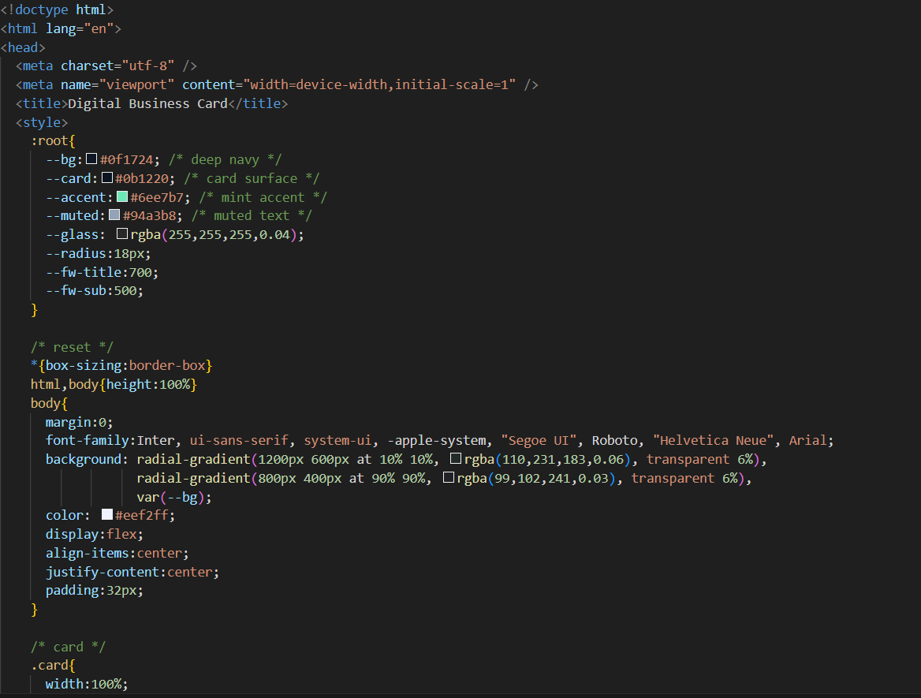

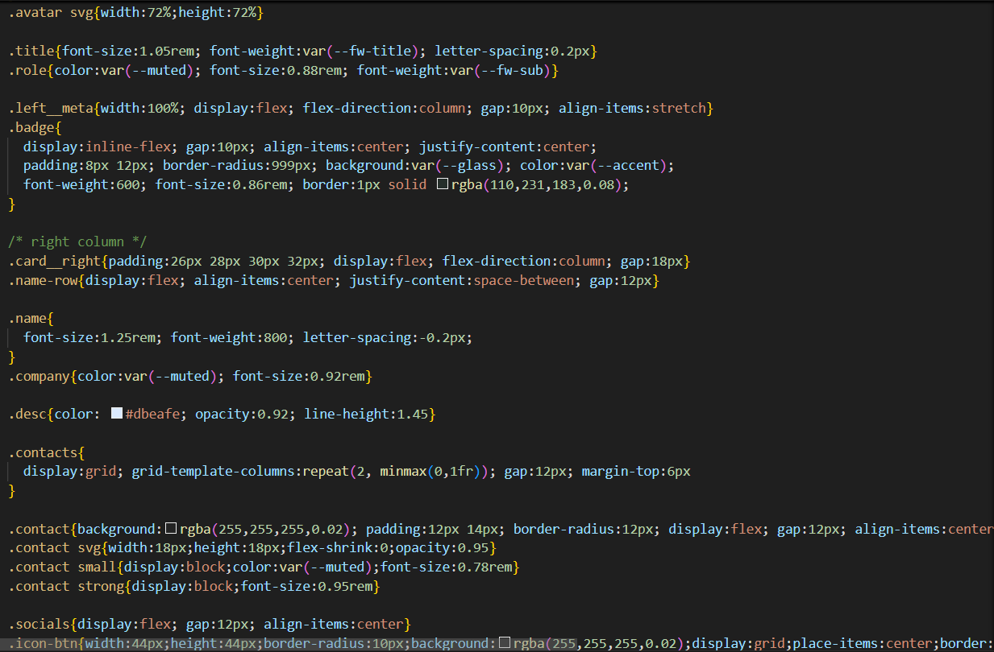

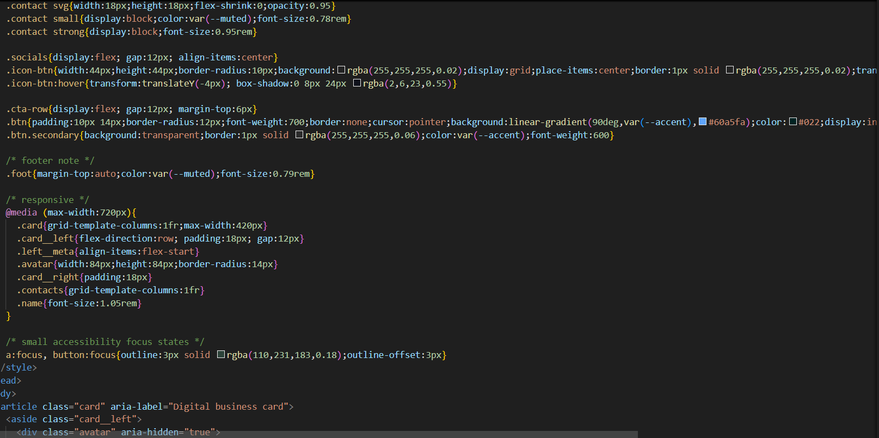

**Sample Output:**

**13.Conclusion:**

This project helped me understand how HTML can be used to build a personal profile page. I learned how to organize content using semantic tags like and , and how to link external profiles using anchor tags. It was a practical way to apply HTML methods for real-world use, and it gave me a strong foundation for creating online portfolios.

We learnt to apply various styling aplications and how to enhance our work using the features and attributes of html.

**14.Reference:**

• L&T LMS: <https://learn.lntedutech.com/Landing/MyCourse>   
• MDN Web Docs   
• CSS-Tricks   
• W3Schools   
• Font Awesome documentation